**Assignment Module 10 API**

1. **to test in above API which is passed in parameter as a column in user module to check the registration performed or not and get the result is coming or not (Method=POST)**

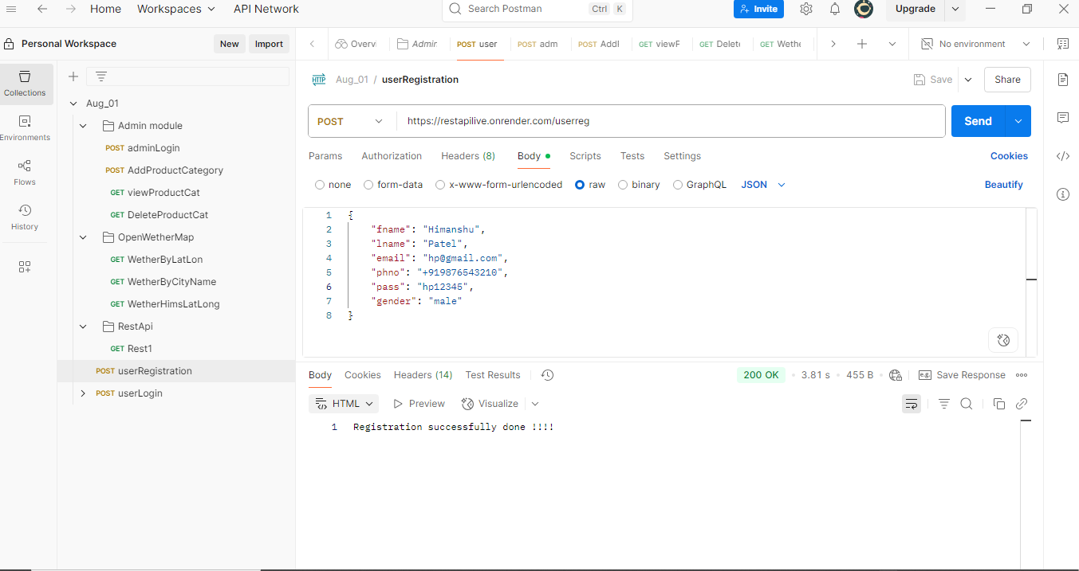

1. **to test in above API which is performed login wit using parameter in user module and check generate token or not (Method=POST)**

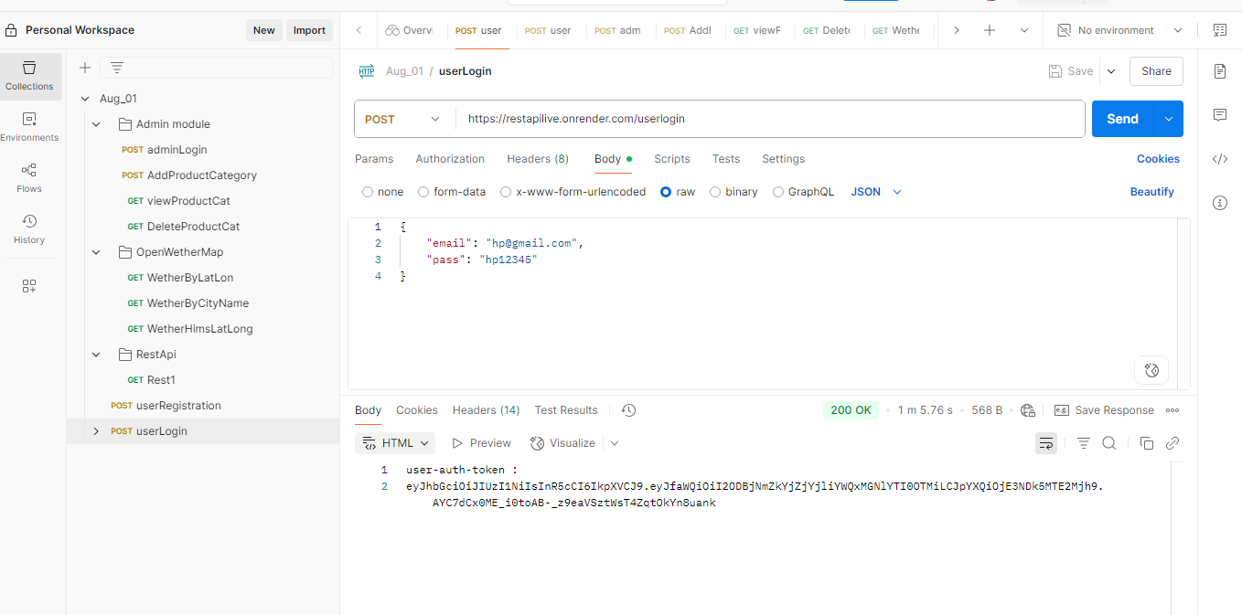

1. **to test in above API which is performed login wit using parameter in admin module and check generate token or not (Method=POST)**

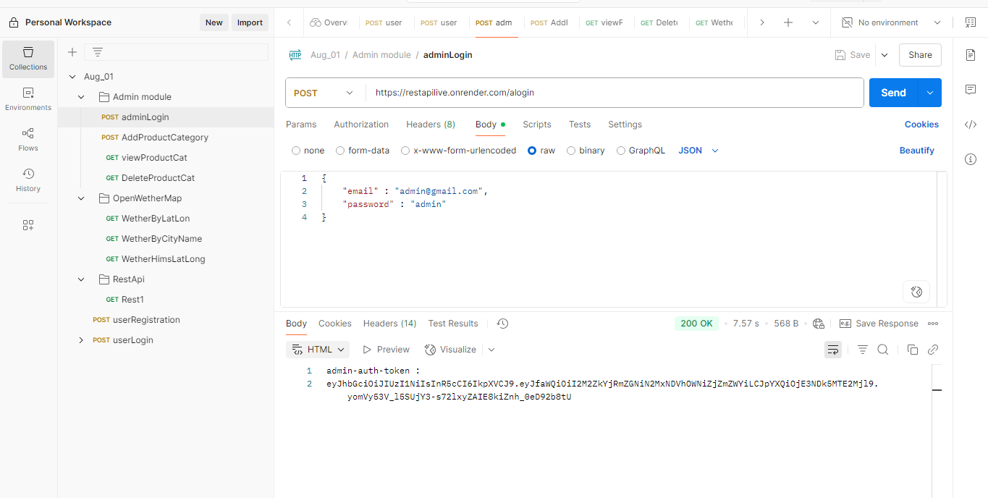

1. **to test in above API which is performed login wit using parameter in admin module and check generate token header : [admin-auth-token : got from admin login] and add category with the help of token (Method= POST)**

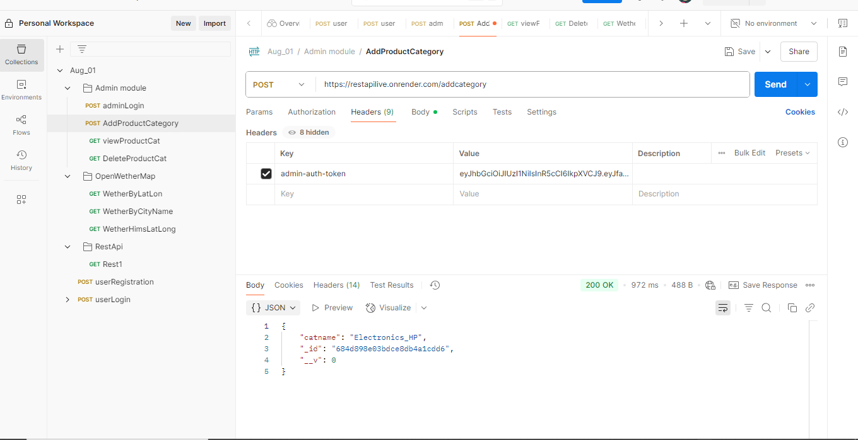

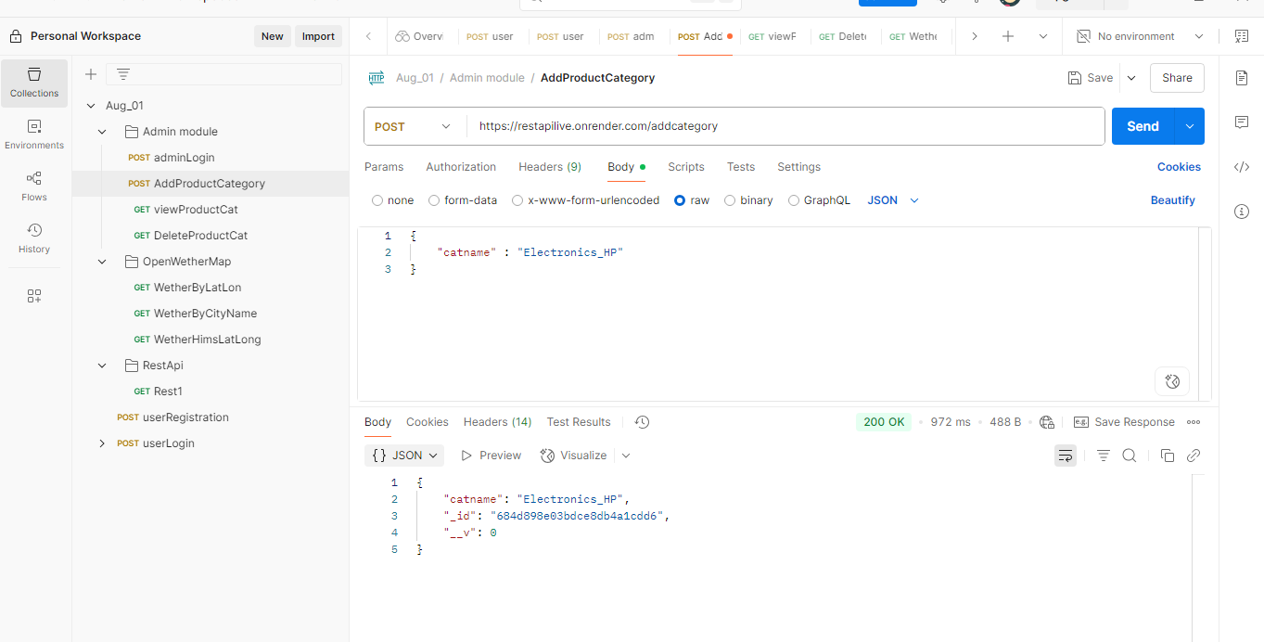

1. **to test in above API which is performed login wit using parameter in admin module and check generate token [admin-auth-token : got from admin login] to display all the category (Method=GET)**

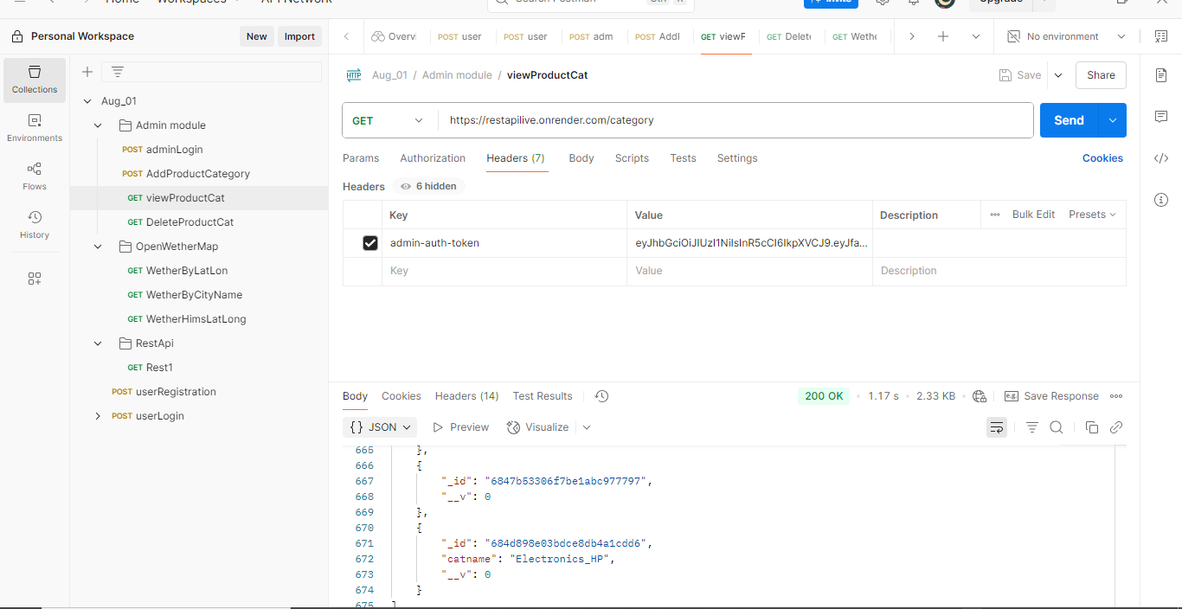

1. **to test in above API which is performed login wit using parameter in admin module and check generate token[admin-auth-token : got from admin login] to delete the category (Method=GET)**

